Filed by Roth CH Acquisition IV Co.

Pursuant to Rule 425 under the Securities Act of 1933

and deemed filed pursuant to Rule 14a-12

of the Securities Exchange Act of 1934

Subject Company: Roth CH Acquisition IV Co.

Commission File No.: 001-40710

The following was made available to certain followers of Tigo Energy, Inc. on December 6, 2022 on its LinkedIn, Twitter and Facebook.
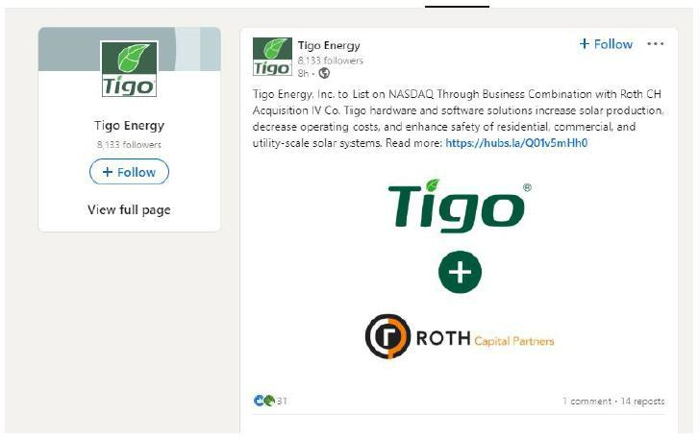

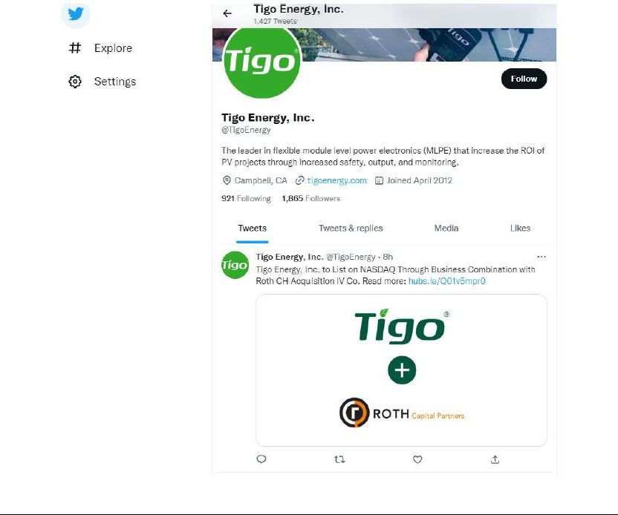

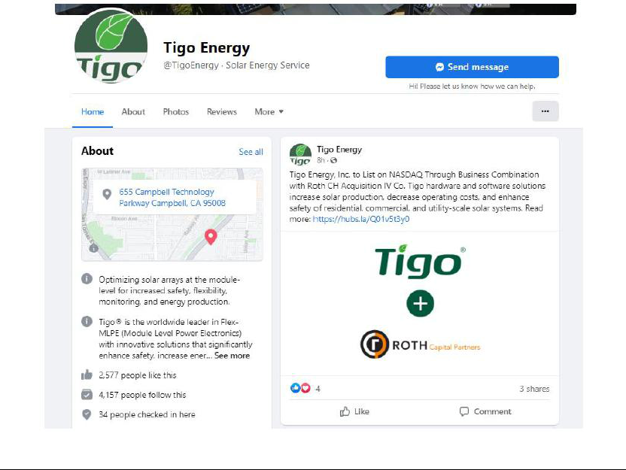

Additional Information and Where to Find It

This communication relates to the proposed business combination between Tigo Energy, Inc. (“Tigo”) and Roth CH Acquisition IV Co. (“Roth”) (the “Business Combination”). In connection with the Business Combination, Roth intends to file a registration statement, which will include a preliminary proxy statement/prospectus, with the SEC. The proxy statement/prospectus will be sent to shareholders of Rot. This communication is not a substitute for the proxy statement/prospectus. INVESTORS AND SECURITY HOLDERS AND OTHER INTERESTED PARTIES ARE URGED TO READ THE PROXY STATEMENT/PROSPECTUS AND ANY OTHER RELEVANT DOCUMENTS THAT HAVE BEEN FILED OR WILL BE FILED WITH THE SEC, AS WELL AS ANY AMENDMENTS OR SUPPLEMENTS TO THESE DOCUMENTS, CAREFULLY AND IN THEIR ENTIRETY WHEN THEY BECOME AVAILABLE BECAUSE THEY WILL CONTAIN IMPORTANT INFORMATION ABOUT TIGO, ROTH, THE BUSINESS COMBINATION AND RELATED MATTERS. The documents filed or that will be filed with the SEC relating to the Business Combination (when they are available) can be obtained free of charge from the SEC’s website at www.sec.gov. These documents (when they are available) can also be obtained free of charge from Roth upon written request at Roth CH Acquisition IV Co., 888 San Clemente Drive, Suite 400, Newport Beach, CA, 92660.

Participants in Solicitation

This communication is not a solicitation of a proxy from any investor or security holder. However, Roth, Tigo, and certain of their directors and executive officers may be deemed to be participants in the solicitation of proxies in connection with the Business Combination under the rules of the SEC. Information about Roth’s directors and executive officers and their ownership of Roth’s securities is set forth in filings with the SEC, including Roth’s Annual Report on Form 10-K filed with the SEC on April 7, 2022. To the extent that holdings of Roth’s securities have changed since the amounts included in Roth’s Annual Report on Form 10-K, such changes have been or will be reflected on Statements of Changes in Ownership on Form 4 filed with the SEC. Additional information regarding the participants will also be included in the proxy statement/prospectus, when it becomes available. When available, these documents can be obtained free of charge from the sources indicated above.

No Offer or Solicitation

This communication is not intended to and shall not constitute a proxy statement or the solicitation of a proxy, consent or authorization with respect to any securities in respect of the Business Combination and shall not constitute an offer to sell or the solicitation of an offer to buy or subscribe for any securities or a solicitation of any vote of approval, nor shall there be any sale, issuance or transfer of securities in any jurisdiction in which such offer, solicitation or sale would be unlawful prior to registration or qualification under the securities laws of any such jurisdiction.

Forward-Looking Statements

This communication contains “forward-looking statements” within the meaning of the Private Securities Litigation Reform Act of 1995. Such statements include, but are not limited to, statements about future financial and operating results, our plans, objectives, expectations and intentions with respect to future operations, products and services; and other statements identified by words such as “will likely result,” “are expected to,” “will continue,” “is anticipated,” “estimated,” “believe,” “intend,” “plan,” “projection,” “outlook” or words of similar meaning. These forward-looking statements include, but are not limited to, statements regarding Tigo’s industry and market sizes, future opportunities for Roth and Tigo, and their respective estimated future results and the Business Combination, the expected transaction and ownership structure and the likelihood and ability of the parties to successfully consummate the Business Combination. Such forward-looking statements are based upon the current beliefs and expectations of our management and are inherently subject to significant business, economic and competitive uncertainties and contingencies, many of which are difficult to predict and generally beyond our control. Actual results and the timing of events may differ materially from the results anticipated in these forward-looking statements.

In addition to factors previously disclosed or that will be disclosed in Roth’s reports filed with the SEC and those identified elsewhere in this communication, the following factors, among others, could cause actual results and the timing of events to differ materially from the anticipated results or other expectations expressed in the forward-looking statements: (1) the occurrence of any event, change or other circumstances that could give rise to the termination of the merger agreement or could otherwise cause the transactions contemplated therein to fail to close; (2) the outcome of any legal proceedings that may be instituted against Roth, Tigo, or others following the announcement of the Business Combination and any definitive agreements with respect thereto; (3) the inability to complete the Business Combination due to the failure to obtain approval of the Shareholders of Roth or Tigo; (4) the inability of Tigo to satisfy other conditions to closing; (5) changes to the proposed structure of the Business Combination that may be required or appropriate as a result of applicable laws or regulations or as a condition to obtaining regulatory approval of the Business Combination; (6) the ability to meet stock exchange listing standards in connection with and following the consummation of the Business Combination; (7) the risk that the Business Combination disrupts current plans and operations of Tigo as a result of the announcement and consummation of the Business Combination; (8) the ability to recognize the anticipated benefits of the Business Combination, which may be affected by, among other things, competition, the ability of Roth to grow and manage growth profitably, grow its customer base, maintain relationships with customers and suppliers and retain its management and key employees;

- the impact of the COVID-19 pandemic on the business of Tigo and Roth (including the effects of the ongoing global supply chain shortage); (10) Tigo’s limited operating history and history of net losses; (11) costs related to the Business Combination; (12) changes in applicable laws or regulations; (13) the possibility that Tigo or Roth may be adversely affected by other economic, business, regulatory, and/or competitive factors; (14) Tigo’s estimates of expenses and profitability; (15) the evolution of the markets in which Tigo competes; (16) the ability of Tigo to implement its strategic initiatives and continue to innovate its existing products; (17) the ability of Tigo to adhere to legal requirements with respect to the protection of personal data and privacy laws; (18) cybersecurity risks, data loss and other breaches of Tigo’s network security and the disclosure of personal information; and (19) the risk of regulatory lawsuits or proceedings relating to Tigo’s products or services.

Actual results, performance or achievements may differ materially, and potentially adversely, from any projections and forward-looking statements and the assumptions on which those forward-looking statements are based. There can be no assurance that the data contained herein is reflective of future performance to any degree. You are cautioned not to place undue reliance on forward-looking statements as a predictor of future performance as projected financial information and other information are based on estimates and assumptions that are inherently subject to various significant risks, uncertainties and other factors, many of which are beyond our control. All information set forth herein speaks only as of the date hereof in the case of information about Roth and Tigo or the date of such information in the case of information from persons other than Roth and Tigo, and we disclaim any intention or obligation to update any forward-looking statements as a result of developments occurring after the date of this communication. Forecasts and estimates regarding Tigo’s industry and end markets are based on sources we believe to be reliable, however, there can be no assurance these forecasts and estimates will prove accurate in whole or in part. Annualized, pro forma, projected and estimated numbers are used for illustrative purpose only, are not forecasts and may not reflect actual results.

